**ST. XAVIER’S COLLEGE**

**(Affiliated to Tribhuvan University)**

**Maitighar, Kathmandu**



**SIMULATION AND MODELING LAB REPORT #08**

**SUBMITTED BY:**

Pradeep Dahal

017BSCIT029

3rd year/ 5th Sem

|  |  |
| --- | --- |
|  | Signature |
| Mr. Ganesh Yogi  (Lecturer) |  |
| Department of Computer Science | |

**SUBMITTED TO:**

**STATEMENT:** A machine tool in a manufacturing shop is turning out parts at the rate of one every 5 minutes. As they are finished, the parts go to an inspector, who takes 4 +- 3 minutes to examine each one. Here, one inspector is engaged for inspection as a facility who after inspection, rejects 10% of parts Each part will be represented by one transaction and the time unit selected for the problem will be 1 minute.

Now, represent the system in block diagram using GPSS.

**THEORY**

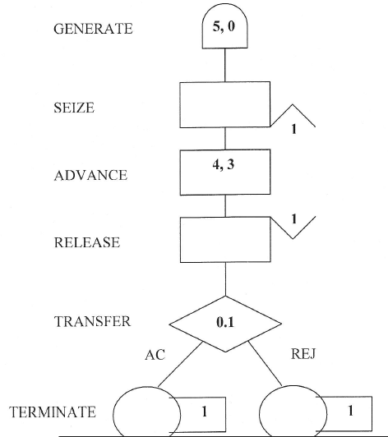

Figure 1 Block Diagram

**GENERATE BLOCK**

This block will produce a flow of transactions with inter-arrival times determined by the attribute values. The label is optional. The distribution of inter-arrival times follows a uniform probability distribution.

**SYNTAX:**

line number label GENERATE A,B,C,D,E

**ATTRIBUTES:**

A = average value of uniform distribution

B = half-width of uniform distribution

C = time delay before first transaction is generated

D = maximum number of transactions generated

E = priority allocated to transactions

**RELEASE** **BLOCK:**

A transaction entering this block informs GPSS that it is giving up ownership of the facility named in its attribute value. The label is optional.

SYNTAX:

* *line number label*RELEASE A

ATTRIBUTES:

* A = name of facility (for example: runaway)

* By giving up ownership of the facility, the transaction makes it available for another transaction that may be waiting to use it.

**ADVANCE BLOCK**

This block represents the servicing of a transaction. The servicing times follow a uniform probability distribution. The label is optional.

**SYNTAX:**

line number label ADVANCE A,B

**ATTRIBUTES:**

A = average value of uniform distribution

B = half-width of uniform distribution

* A transaction entering this block will be delayed by a time interval chosen at random from the specified probability distribution.

**TRANSFER BLOCK**

This block will take transactions entering it and transfer them to each of two different destinations according to laid down proportions. For example:

200 TRANSFER 0.95, EXIT, REPAIR

In this case 95% of all transactions entering the TRANSFER block will go to the program line labelled REPAIR and 5% will go to the program line labelled EXIT. If the second attribute "EXIT" is replaced by a "comma", then the 5% will go to the next block in the program.

**SYNTAX:**

line number label TRANSFER A,B,C

**ATTRIBUTES:**

A = probability value (0 to 1)

B = proportion of (1-A) transactions transferred to this labelled location

C = proportion A transactions transferred to this labelled location

**TERMINATE BLOCK**

This block destroys any transaction entering it and removes it from computer memory. Each time a transaction enters this block it decrements a counter by an amount equal to its attribute value. The counter is set by the user upon starting the simulation.

**SYNTAX:**

line number label TERMINATE A

**ATTRIBUTES:**

A = decrements simulation counter by this amount

* When the counter, set at the beginning of the simulation, reaches zero then the simulation is complete and a statistical report is produced on the outcome of the simulation

**CODING**

GENERATE 5, 0

SEIZE 1

ADVANCE 4, 3

RELEASE 1

TRANSFER 0.1, ACC, REJ

ACC TERMINATE 1

REJ TERMINATE 1

**RESULT**

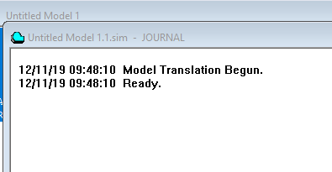

**Figure 2 Create Simulation**

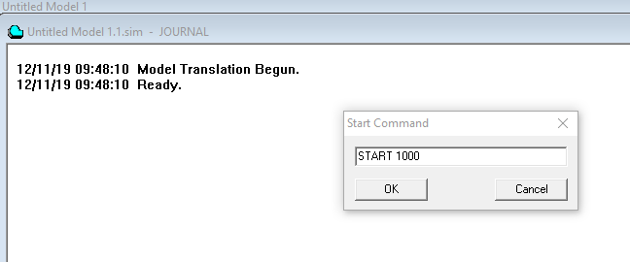

**Figure 3 Start the simulation**

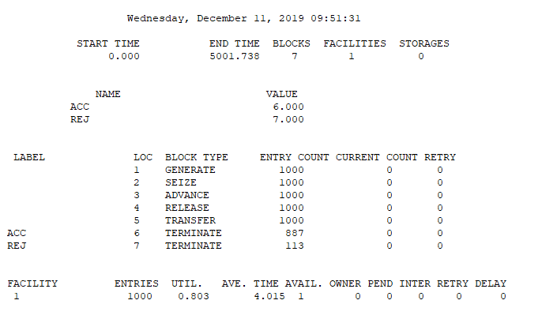

Figure 4 Generate Report

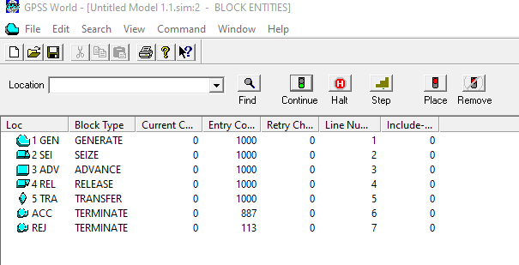

Figure 5 Simulate Block Windows

**CONCLUSION**

Hence, the Manufacturing Shop Model-2 was simulated using GPSS.